📘 PROJECT DOCUMENTATION

🔹 1. Project Title
Project Name:
Personal Portfolio Website

🔹 2. Project Description
Overview:
This project is a personal portfolio website designed to showcase my skills, projects, and achievements in a professional way. It serves as an online resume where visitors can learn about me, view my work, and contact me easily. The website is responsive and works across different devices like mobile, tablet, and desktop.
Objective:
It provides a centralized platform to present my personal and professional information, making it easier for recruiters or others to evaluate my skills and projects without needing multiple documents.
Technologies Used:
- HTML
- CSS
- JavaScript

🔹 3. Features
- Responsive design (works on mobile and desktop)
- About Me section with personal details
- Projects section to showcase work
- Contact section with details or form

🔹 4. Setup Instructions
- Download / Clone the project
- Open the project folder
- No installation required
- Run the project
  - Open index.html in browser

🔹 5. Screenshots
📸 Screenshot 1: (Home Page)
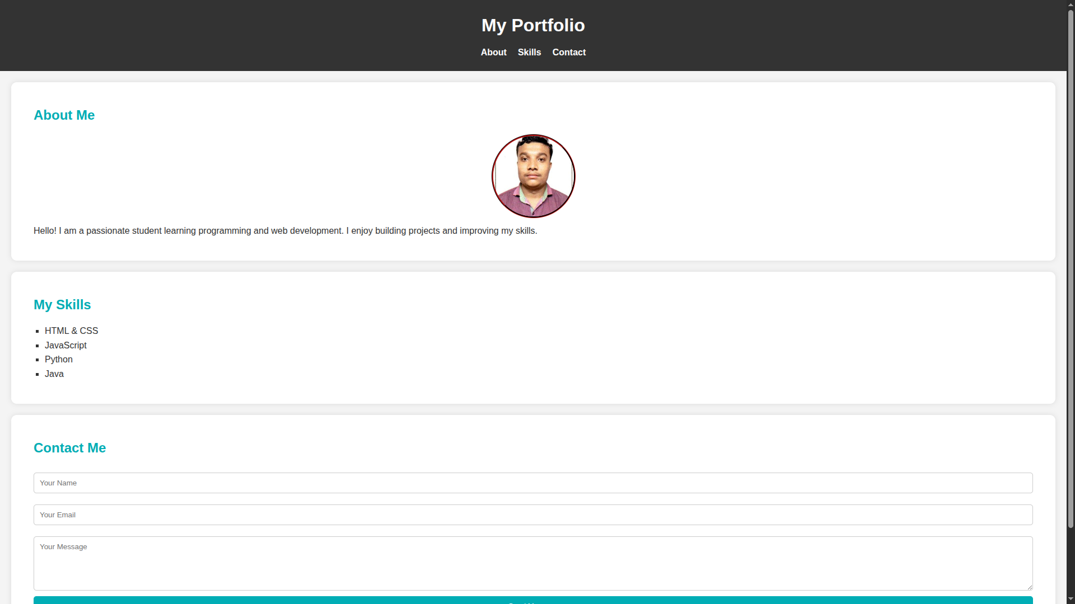
📸 Screenshot 2: (Projects Section)
[Insert Image Here]
📸 Screenshot 3: (Contact Section)
[Insert Image Here]

🔹 6. Project Explanation
- The website is built using HTML for structure, CSS for styling, and JavaScript for interactivity.
- Navigation links allow users to move between sections like Home, About, Projects, and Contact.
- Each section is designed to display specific information in a clean and organized way.
- Users can scroll or click navigation buttons to explore the website easily.

🔹 7. Folder Structure (Optional)
project-folder/
│── index.html
│── style.css
│── script.js

🔹 8. Challenges Faced (Optional)
While developing the project, I faced issues with responsive design and layout alignment. I solved these problems using CSS Flexbox and media queries to make the design adaptable to different screen sizes.

🔹 9. Future Improvements (Optional)
- Add backend integration for contact form
- Include animations and advanced UI effects
- Add blog section
- Deploy the website online

🔹 10. Conclusion
This project helped me understand the fundamentals of web development and improve my design and coding skills. It also serves as a professional platform to present my work and achievements.

🔹 11. Author Details
Name: MANAS JANA
Course / College:B.tech / college of engineering and management, Kolaghat
Year:2026

